Bioinformatic Analysis of Allocated Primer Pair 8 And Human IRX1 Gene
College of Engineering, Environment, and Sciences, Coventry University
5008BIO: Human Genetic Diversity
Dr Sarah Forbes-Robertson
10 December, 2025

- Introduction
Primer 8 is recognised as a primer pair for the IRX1 Gene as a result of running it in BLAST (2025). This report aims to highlight the genetic context, disorders, and bioinformatic analysis of the human IRX1 gene. It also suggests a suitable model animal for further study of the genetic disorder from the malfunction of the IRX1 gene.

- Gene Identification via BLAST

Figure 1
Primer-Blast Result from Primer Pair 8
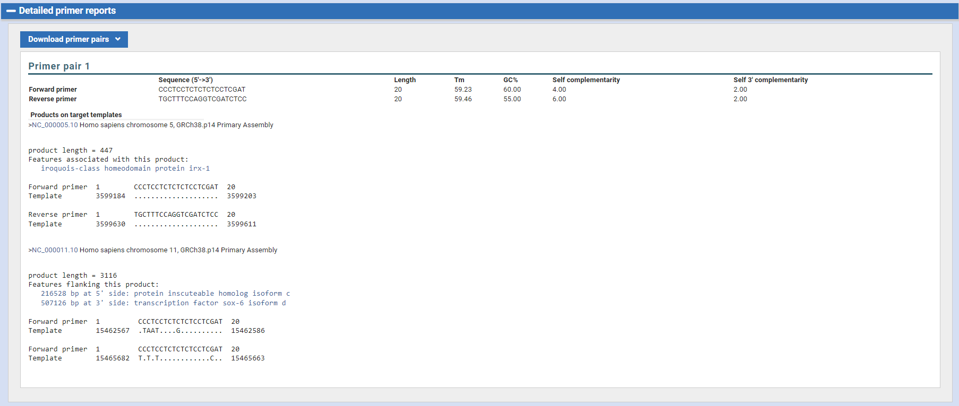
From primer-BLAST (Ye et al., 2012)

Figure 1 shows the two matching results of Primer-BLAST from the allocated primer pair. As the latter does not fully complement the primers, the former gene was identified as the corresponding one. To derive the result, the allocated primer pair (Primer Pair 8) and target organism (Homo Sapiens) were input. (Fig. 2)

Figure 2
Primer-Blast Input of Primer Pair 8
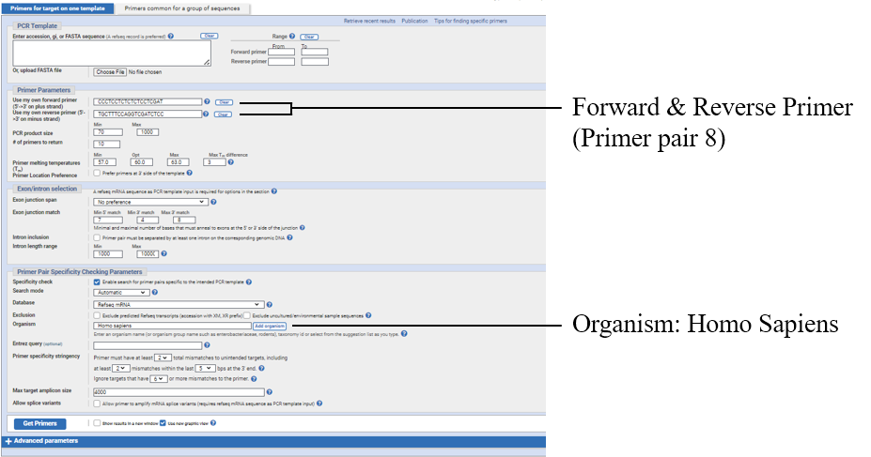
From primer-BLAST (Ye et al., 2012)
- Target Gene Analysis
  - Genetic Context
Figure 3
Genomic Context of the IRX1 Gene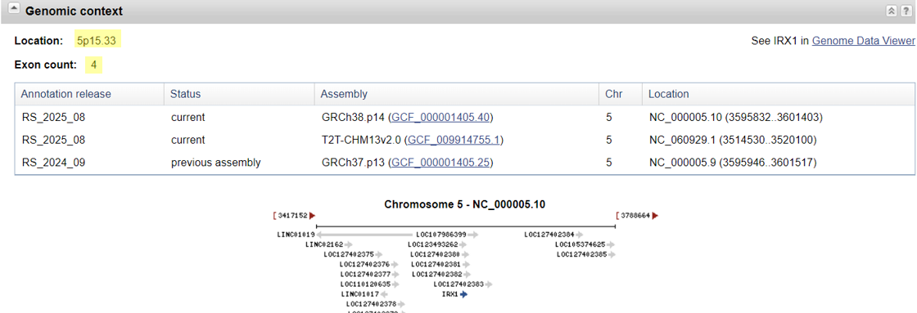
Note. Location and exon count of the gene were highlighted.
From NCBI, 2025

The IRX1 gene, gene ID 79192, encodes the Iroquois homeobox (IRX) protein, and the gene product works as a tumour, neck and head cancer suppressor. (NCBI, 2025) Located in chromosome 5 (5p15.33 cluster), the IRX1 gene is a forward strand with a length of 5572 bp. (Fig. 3) The pseudogene of the IRX1 gene is located on chromosome 13 (NIH RefSeq, 2011)

  - Genetic Structure
Figure 4
Position of Coding Sequence and Translated Amino Acids
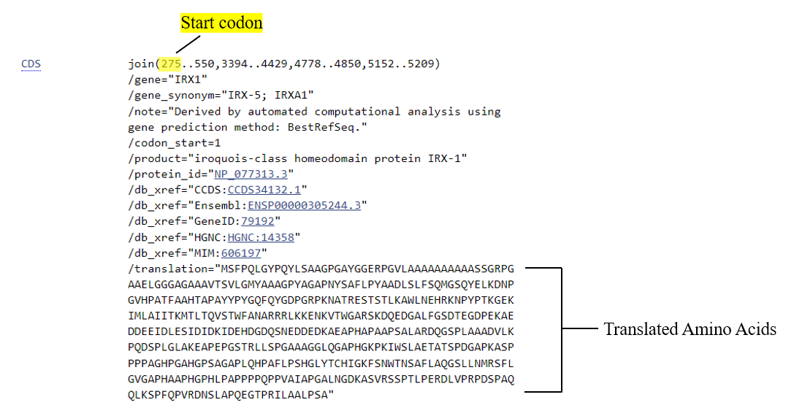
From NCBI, 2025

Figure 4 represents the coding sequence of the IRX1 gene: the position of the start codon is 275 bp and the stop codon location is 5209, with 4 exons. Flanking genes on chromosome 5 are LINC01019 (upstream) and LOC107986399 (downstream), which are both non-coding RNA (NIH, 2025a; NIH, 2025b) and influence cell and tissue specificity of the IRX1 gene. (Fig. 5) Other than the flanking regions, IRX2 and ADAMTS16 genes are adjacent coding genes on chromosome 5, 5’ direction and 3’ direction, respectively.

Figure 5
Flanking Genes on the Chromosome
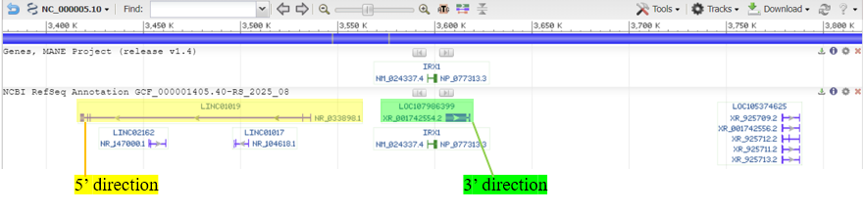
From NCBI, 2025

- Function, Expression & Regulation of the Gene
4.1 Gene Function & Expression
There are six existing IRX genes in total in humans, all encoding a member of the Iroquois homeobox (IRX) protein family. These genes play crucial roles in the initial specification of the vertebrate neuroectoderm and subdivision of the anterior-posterior and dorso-ventral axes of the neuroectoderm, as the IRX protein regulates cell specification and differentiation, regionalisation and patterning of tissues and organs during embryonic development. (Gómez-Skármeta and Modolell, 2002)
The IRX1 gene, in particular, is associated with foregut organs such as the lung. (Jiang et al., 2011) It is also identified as a tumour suppressor gene in gastric cancer, while also suppressing head and neck squamous cell carcinoma (HNSCC). (Bennett et al., 2008) When poorly regulated, on the other hand, it is increasingly associated with congenital disorders, including congenital heart disease and neurodevelopmental abnormalities. (Goutam et al., 2025)
Bioinformatics databases consistently place the IRX1 gene within a developmental regulatory pathway, reflecting its conserved role as a homeobox transcription factor crucial for embryonic patterning, including cardiac, skeletal, lung, and tooth development.
Figure 6
Bulk Tissue Gene Expression for IRX1
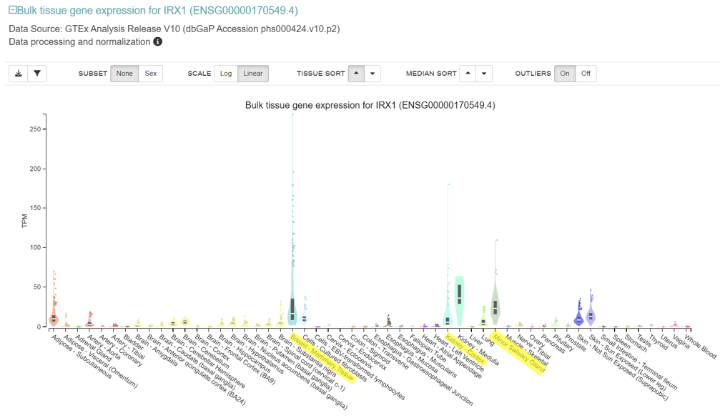
From GTEx, 2025

The IRX1 gene expression is significantly low in most of the tissues except the mammary tissue of the breast, the cortex of the kidney, and the minor salivary gland, reaching over 100 TPM (Transcription per Million). (Fig. 6) This shows the high specificity and context-dependent aspect of the gene. Figure 7 illustrates the single-cell expression, which shows the reason why the expression was high in certain tissues. The IRX1 gene is only clearly expressed upon certain epithelial subtypes: mammary epithelial cells, alveolar type 2 epithelial cells in lungs, mucosal epithelial cells, and suprabasal keratinocytes of the skin. This again suggests the pronounced heterogeneity and context-dependent regulatory role of the gene rather than ubiquitous transcription. The gene has no impact on the immune or metabolic system of the body, which is consistent with the pattern.

Figure 7
Single Cell Expression of the IRX1 Gene
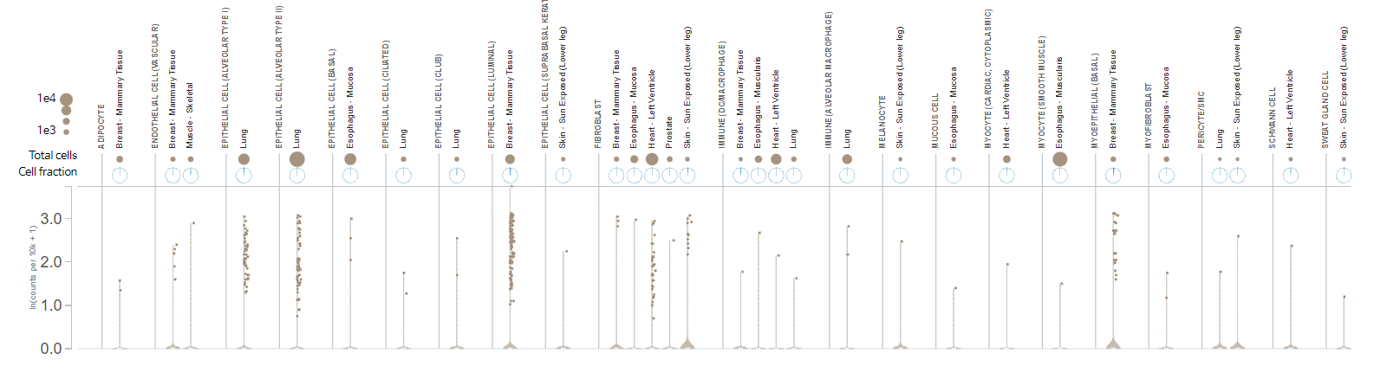
From GTEx, 2025

4.2 Regulation of the Gene
The expression of the IRX1 gene is governed by the transcriptional regulatory network, including auto-regulatory loops, Cis-Regulatory Elements (CREs), and epigenetic mechanisms. Transcriptional factors include the promoters ENSR5_84T3T and ENSR5_93FKR, which are located on the 5’ and 3’ ends direction respectively. (fig. 8) The ENCODE project in 2015 revealed that the size of ENSR5_93FKR is 450-650 bp long, which indicates that there can be a utilisation of multiple transcription start sites (TSSs) or alternative promoters, whilst there is no data present for ENSR5_84T3T. Other predicted factors of the regulation of the IRX1 genes are found via the El Dorado program from Genomatix in 2014: NRF1, ZF5, E2F cell cycle regulators, and brachyury.

Figure 8
Locations of the IRX1 Gene Promoters
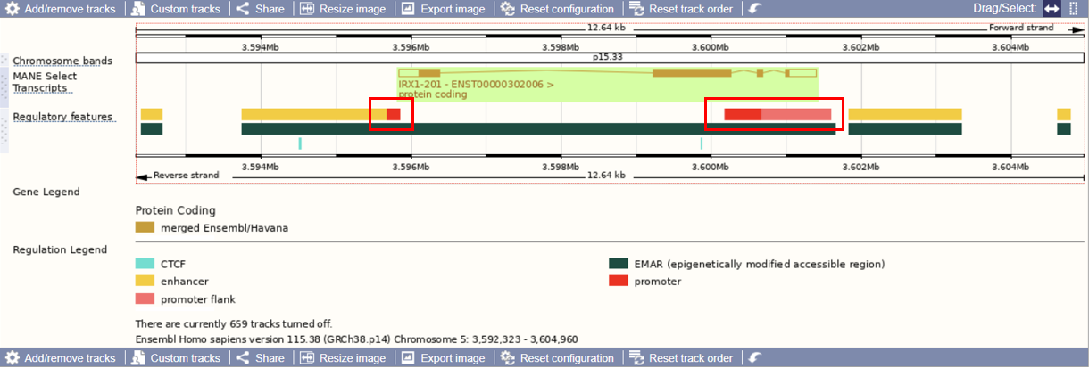From ENSEMBL (Dyer et al., 2025)

While there are transcriptional factors that influence the expression of the IRX1 gene, Cis-Regulatory Elements (CREs), including enhancers and silencers, also modulate the gene. Table 1 illustrates examples of the enhancers with their Transcription Start Site (TSS) distance and GeneHancer (GH) score, which refers to the strength of the regulatory elements’ association. GH05J003394 works both as a promoter and an enhancer and it is a prime example of a proximal regulatory switch. On the other hand, GH05J003627 is located relatively far away from the TSS (+31.9 kb). This enhancer employs chromatin looping to regulate the gene, which facilitates a physical interaction between the distal and proximal promoter regions. This allows the delivery of activating transcriptional signals to control the gene’s expression. (Kadauke and Blobel, 2008)

Table 1
Enhancers of the IRX1 Gene
Identifier | GH Type | TSS Distance | GH Score
GH05J003394 | Promoter/Enhancer | +0.7 kb | 1.9
GH05J003627 | Enhancer | +31.9 kb | 0.4
GH05J003309 | Enhancer | -284.7 kb | 1.0
Note. This table presents a selected subset of the total 156 elements identified in the original data, chosen for mechanistic analysis.
From GeneCards (Stelzer et al., 2016)

As previously mentioned, the IRX1 gene works as a tumour suppressor gene on gastric cancer, while also suppressing head and neck squamous cell carcinoma. This is because the gene is influenced by its epigenetic state. The silencing of the IRX1 gene occurs via hypermethylation of the CpG islands located on the promoter region, not through mutation in these cancers. The suppression of the IRX1 expression results in the loss of its inhibitory function, leading to tumour progression. (Küster et al., 2020; Guo et al., 2010)

- Protein Encoded by the Gene
Iroquois-class homeodomain protein IRX-1, also known as Iroquois homeobox protein 1, is encoded by the IRX1 gene. The protein is 480 aa in length with a molecular mass of 49,621 Da. (UniProt, 2004) IRX1 belongs to the homeobox family (IRX1-IRX6) and contains a DNA binding spot of 57 amino acid length: 125-188. After translation, the Iroquois homeobox protein is located in the nucleus, following its function of DNA binding. The 3D modelling of the protein is available on AlphaFold. (fig. 9)

Figure 9
3D Modelling of the Protein IRX-1 with Model Confidence Explained
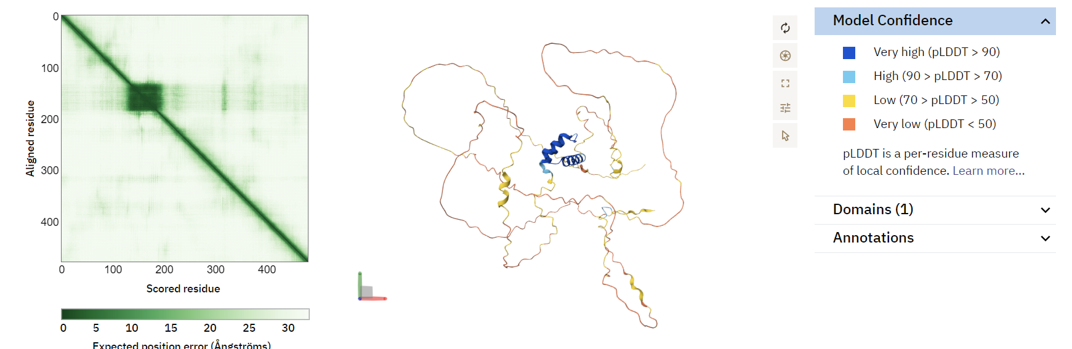
From AlphaFold (Fleming et al., 2025)

Although there is lack of isoform diversity, IRX1 interacts with other regulators such as tumour protein (TP53), RNA binding protein (ELAVL1), and other interactors: HSPA8, INTS5, MCM3AP, MLF2, MTA3, RAB3B, TRPC4AP. These are experimentally validated interactors. (BioGRID 5.0, 2025) Other possible interactors include the homeobox family (fig. 10), which is predicted via integrating co-expression, text mining, and computational predictions by STRING. (2025) There are three post-translational modifications validated for IRX1, all of which are phosphorylation sites. (fig. 11)

Figure 10
Protein IRX1 Interaction Network Inferred by STRING
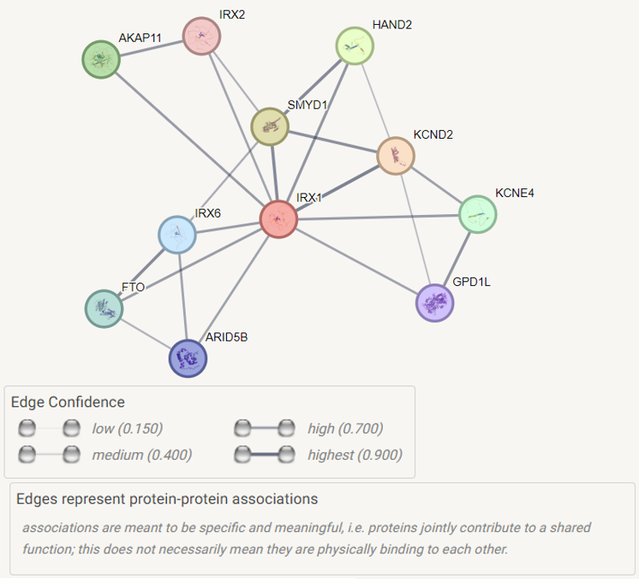
From STRING (von Mering et al., 2005)

Figure 11
PTM Sites of Protein IRX1
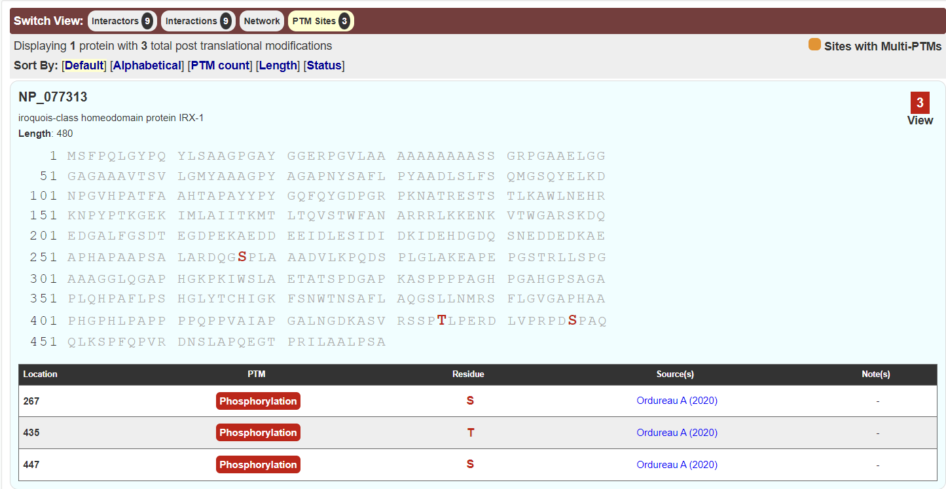
From BioGRID (Oughtred et al., 2021)
- Inherited Genetic Disease Associated with the Gene
The IRX1 gene is essential for normal embryonic patterning and tissue morphogenesis. However, IRX1 has not been directly reported as a cause of inherited genetic disease and it currently remains a candidate gene. Therefore, given the close functional relationship between IRX1 and other IRX family members, this report highlights the inherited genetic disease caused by the gene from the IRX family.
Clinical and genomic studies have shown that malfunctioning of the IRX5 gene led to an autosomal recessive genetic disease called Hamamy syndrome (OMIM #611174). Its symptoms include craniofacial abnormalities, mild micrognathia or osteopenia leading to repeated long bone fractures, enamel hypoplasia, severe myopia, sensorineural or mixed hearing loss, and mild intellectual disability. The disease is extremely rare, with a prevalence of lower than 1/ 1,000,000 and develops in infancy or neonatal. (Orphanet, 2025) To date, the known causative mutations are missense mutations in the IRX5 gene: N166K, 606195.0001 and A150P, 606195.0002, and R168H; 606195.0003. (OMIM, 2024)

- Primer Analysis
The Primer-BLAST analysis has shown that Primer pair 8 is exclusively designed to target genomic DNA of chromosome 5, rather than RNA, as it shows no matches to RefSeq mRNA transcripts. The amplicon size is 447 bp, which makes it unsuitable for qRT-PCR or qPCR as the amplicon size is much longer than the desirable length. (PCR Biosystems, 2022) The amplicon contains the common SNP rs861185 (A/G/T) and several insertion/ deletion mutations. (fig. 12) Therefore, the primers are most likely designed for genomic DNA amplification, such as genotyping or sequencing. This suggests their intended use is for Sanger sequencing to detect SNP rs861185 and other mutations.

Figure 12
SNP and Indel Variation Regions of the Amplicon Visualised by UCSC
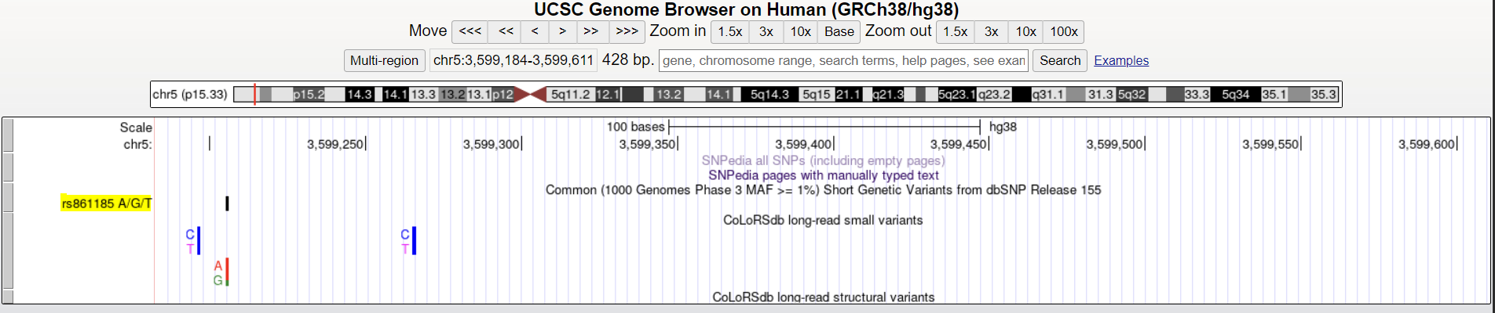
From UCSC Genome Browser (Perez et al., 2025)

Quality-wise, both primers’ melting temperatures (Tm) have hardly any difference (0.17°C), which is lower than 5°C, making it ideal. Moreover, both primers have GC% in between 50-60%, which ensures stable binding of primer and template. (NIJ, 2023) Furthermore, the primers show low scores for self-complementarity and 3'-end complementarity (fig. 1), minimising the risk of primer-dimer formation or hairpin structures that could inhibit the PCR reaction.

- Model Animal
Although there are 702 vertebrate homologs of the IRX1 gene, a suitable model animal for further investigation of the mutation or inherited genetic disease is Mus musculus (house mouse). The IRX1 gene shares strong evolutionary conservation with the murine ortholog (Irx1), including preservation of the homeobox domain. (fig. 13) Previous Irx1 studies have shown that the Irx1 gene is involved in limb development of the mice (Zülch et al., 2001), while regulating processes of cell proliferation, differentiation, and maturation during development of the mouse embryo, precisely affecting the brain, lung, and kidney. (Yu et al., 2017) Because the IRX family plays a central role in early embryonic development and patterning, the mouse provides an appropriate phenotypic outline to model human developmental phenotypes. Furthermore, the availability of existing knockout genes and the feasibility of CRISPR-Cas9-mediated gene manipulation make the mouse an experimentally and biologically relevant model animal. (Cohen, 2016)

Figure 13
Multiple Sequence Alignment of the IRX1 Protein Between Homo sapiens and Mus musculus
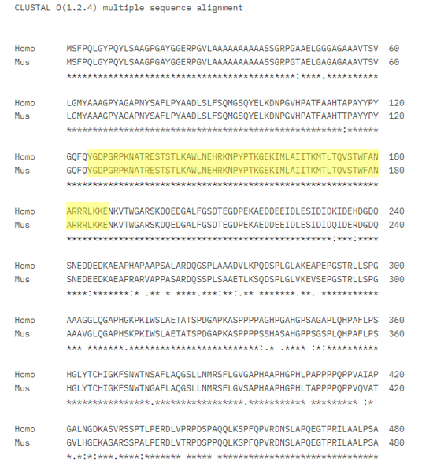
Note. Homeobox domains (125-188) were highlighted in yellow.
From Clustal Omega (Sievers et al., 2011)

- Conclusion
The IRX1 gene encodes a protein that plays a crucial role in embryonic patterning and tissue development. Although no inherited genetic disease has been directly linked with the gene IRX1 to date, evidence from related IRX family members, such as IRX5 provides potential developmental consequences of disruption of IRX regulation: Hamamy syndrome. In addition, the allocated primer pair evaluation showed that it is suitable for genomic DNA amplification with high specificity. The use of Mus musculus as a model animal provides the ground for further studies on the regulation of the gene IRX1 and its potential involvement in human genetic disease. Altogether, this report establishes the understanding of the IRX1 gene and context for future investigation into its regulatory roles and potential contributions to human disease.

1,587 Words
Summary of AI Use
Tool | How is it used in this assignment
Grammarly | To check spelling, grammar, or punctuation errors
Google Gemini 2.5 | To refine academic tone and language clarity

Used Bioinformatics Tools & Databases
Category | Tool/Database | URL
Tools | Primer-BLAST | https://www.ncbi.nlm.nih.gov/tools/primer-blast/
 | Clustal Omega | https://www.ebi.ac.uk/jdispatcher/msa/clustalo
Databases | NCBI (Gene, RefSeq) | https://www.ncbi.nlm.nih.gov/
 | ENSEMBL | https://asia.ensembl.org/index.html?
 | UniProt | https://www.uniprot.org/
 | STRING | https://string-db.org/
 | BioGRID | https://thebiogrid.org/
 | AlphaFold | https://alphafold.ebi.ac.uk/
 | Orphanet | https://www.orpha.net/
 | OMIM | https://www.omim.org/
 | GTEx | https://gtexportal.org/home/
 | GeneCards | https://www.genecards.org/
 | UCSC Genome Browser | https://genome.ucsc.edu/index.html

References
Bennett, K. L., Karpenko, M., Lin, M., Claus, R., Arab, K., Dyckhoff, G., Plinkert, P., Herpel, E.,
Smiraglia, D., & Plass, C. (2008). Frequently Methylated Tumor Suppressor Genes in Head and Neck Squamous Cell Carcinoma. Cancer Research, 68(12), 4494–4499. https://doi.org/10.1158/0008-5472.can-07-6509
Cohen, J. (2016, November 3). “Any idiot can do it.” Genome editor CRISPR could put mutant
mice in everyone’s reach. Www.science.org. https://www.science.org/content/article/any-idiot-can-do-it-genome-editor-crispr-could-put-mutant-mice-everyones-reach
Dyer, S. C., Austine-Orimoloye, O., Azov, A. G., Barba, M., Barnes, I., Barrera-Enriquez, V. P.,
Becker, A., Bennett, R., Beracochea, M., Berry, A., Bhai, J., Bhurji, S. K., Boddu, S., Branco Lins, P. R., Brooks, L., Ramaraju, S. B., Campbell, L. I., Martinez, M. C., Charkhchi, M., & Cortes, L. A. (2025). Ensembl 2025. Nucleic Acids Research, 53(D1), D948–D957. https://doi.org/10.1093/nar/gkae1071
ENCODE Project Consortium. (2012, September 6). An Integrated Encyclopedia of DNA
Elements in the Human Genome. Nature. https://pubmed.ncbi.nlm.nih.gov/22955616/
Fleming, J., Magana, P., Nair, S., Tsenkov, M., Bertoni, D., Pidruchna, I., Lima Afonso, M. Q.,
Midlik, A., Paramval, U., Žídek, A., Laydon, A., Kovalevskiy, O., Pan, J., Cheng, J., Avsec, Ž., Bycroft, C., Wong, L. H., Last, M., Mirdita, M., & Steinegger, M. (2025). AlphaFold Protein Structure Database and 3D-Beacons: New Data and Capabilities. Journal of Molecular Biology, 437(15), 168967. https://doi.org/10.1016/j.jmb.2025.168967
Gómez-Skarmeta, J. L., & Modolell, J. (2002). Iroquois genes: genomic organization and
function in vertebrate neural development. Current Opinion in Genetics & Development, 12(4), 403–408. https://doi.org/10.1016/s0959-437x(02)00317-9
Goutam, R. S., Kaushik, N., Kumar, B., Jung, W., Kumar, S., Lee, S.-H., Lee, U., & Kim, J.
(2025). Multifaceted role of Iroquois signaling in development and diseases. Molecules and Cells, 48(12), 100296. https://doi.org/10.1016/j.mocell.2025.100296
GTEx, The Genotype-Tissue Expression. (2025). GTEx Portal. Gtexportal.org.
https://gtexportal.org/home/gene/IRX1
Guo, X., Liu, W., Pan, Y., Ni, P., Ji, J., Guo, L., Zhang, J., Wu, J., Jiang, J., Chen, X., Cai, Q.,
Li, J., Zhang, J., Gu, Q., Liu, B., Zhu, Z., & Yu, Y. (2010). Homeobox gene IRX1 is a tumor suppressor gene in gastric carcinoma. Oncogene, 29(27), 3908–3920. https://doi.org/10.1038/onc.2010.143
Jiang, J., Liu, W., Guo, X., Zhang, R., Zhi, Q., Ji, J., Zhang, J., Chen, X., Li, J., Zhang, J., Gu,
Q., Liu, B., Zhu, Z., & Yu, Y. (2011). IRX1 influences peritoneal spreading and metastasis via inhibiting BDKRB2-dependent neovascularization on gastric cancer. Oncogene, 30(44), 4498–4508. https://doi.org/10.1038/onc.2011.154
Kadauke, S., & Blobel, G. A. (2008). Chromatin loops in gene regulation. Biochimica et
Biophysica Acta (BBA) - Gene Regulatory Mechanisms, 1789(1), 17–25. https://doi.org/10.1016/j.bbagrm.2008.07.002
Küster, M. M., Schneider, M. A., Richter, A. M., Richtmann, S., Winter, H., Kriegsmann, M.,
Pullamsetti, S. S., Stiewe, T., Savai, R., Muley, T., & Dammann, R. H. (2020). Epigenetic Inactivation of the Tumor Suppressor IRX1 Occurs Frequently in Lung Adenocarcinoma and Its Silencing Is Associated with Impaired Prognosis. Cancers, 12(12), 3528. https://doi.org/10.3390/cancers12123528
National Center for Biotechnology Information. (2025). iroquois homeobox 1. NCBI.
https://www.ncbi.nlm.nih.gov/datasets/gene/79192/
NIH. (2025a). LINC01019 long intergenic non-protein coding RNA 1019 [Homo sapiens
(human)] – Gene - NCBI. Nih.gov. https://www.ncbi.nlm.nih.gov/gene/?term=LINC01019
NIH. (2025b). LOC107986399 uncharacterized LOC107986399 [Homo sapiens (human)] –
Gene – NCBI. Nih.gov. https://www.ncbi.nlm.nih.gov/gene/?term=107986399#gene-expression
NIJ. (2023, July 31). Archived | DNA Amplification | GC Content Percentage | National Institute
of Justice. Nij.ojp.gov. https://nij.ojp.gov/nij-hosted-online-training-courses/dna-amplification/overview/primer-design/gc-content-percentage
Online Mendelian Inheritance in Man, OMIM. (2024). Entry - #611174 - HAMAMY
SYNDROME; HMMS - OMIM - (OMIM.ORG). Omim.org.https://www.omim.org/entry/611174?search=hamamy%20disease&highlight=disease%2Chamamy
Orphanet. (2025). Orphanet: Facial dysmorphism-ocular anomalies-osteopenia-intellectual
disability-dental anomalies syndrome. Orpha.net. https://www.orpha.net/en/disease/detail/314555?name=hamamy&mode=name
Oughtred, R., Rust, J., Chang, C., Breitkreutz, B., Stark, C., Willems, A., Boucher, L., Leung,
G., Kolas, N., Zhang, F., Dolma, S., Coulombe‐Huntington, J., Chatr‐aryamontri, A., Dolinski, K., & Tyers, M. (2021). The BioGRID database: A comprehensive biomedical resource of curated protein, genetic, and chemical interactions. Protein Science, 30(1), 187–200. https://doi.org/10.1002/pro.3978
PCR Biosystems. (2022, October 14). What should the length of the amplicon be? PCR
Biosystems. https://pcrbio.com/row/resources/faqs/qpcrbio-hrm-mix/what-should-the-length-of-the-amplicon-be/
Perez, G., Barber, G. P., Benet-Pages, A., Casper, J., Clawson, H., Diekhans, M., Fischer, C.,
Gonzalez, J. N., Hinrichs, A. S., Lee, C. M., Nassar, L. R., Raney, B. J., Speir, M. L., van Baren, M. J., Vaske, C. J., Haussler, D., Kent, W. J., & Haeussler, M. (2025). The UCSC Genome Browser database: 2025 update. Nucleic Acids Research, 53(D1), gkae974. https://doi.org/10.1093/nar/gkae974
Stelzer, G., Rosen, N., Plaschkes, I., Zimmerman, S., Twik, M., Fishilevich, S., Stein, T. I.,
Nudel, R., Lieder, I., Mazor, Y., Kaplan, S., Dahary, D., Warshawsky, D., Guan-Golan, Y., Kohn, A., Rappaport, N., Safran, M., & Lancet, D. (2016). The GeneCards Suite: From Gene Data Mining to Disease Genome Sequence Analyses. Current Protocols in Bioinformatics, 54(1), 1.30.1–1.30.33. https://doi.org/10.1002/cpbi.5
Sievers, F., Wilm, A., Dineen, D., Gibson, T. J., Karplus, K., Li, W., Lopez, R., McWilliam, H.,
Remmert, M., Soding, J., Thompson, J. D., & Higgins, D. G. (2011). Fast, scalable generation of high-quality protein multiple sequence alignments using Clustal Omega. Molecular Systems Biology, 7(1), 539–539. https://doi.org/10.1038/msb.2011.75
von Mering, C., Jensen, L. J., Snel, B., Hooper, S. D., Krupp, M., Foglierini, M., Jouffre, N.,
Huynen, M. A., & Bork, P. (2005). STRING: known and predicted protein-protein associations, integrated and transferred across organisms. Nucleic Acids Research, 33(Database issue), D433–D437. https://doi.org/10.1093/nar/gki005
Ye, J., Coulouris, G., Zaretskaya, I., Cutcutache, I., Rozen, S., & Madden, T. L. (2012). Primer-
BLAST: A tool to design target-specific primers for polymerase chain reaction. BMC Bioinformatics, 13(1). https://doi.org/10.1186/1471-2105-13-134
Yu, W., Li, X., Eliason, S., Romero-Bustillos, M., Ries, R. J., Cao, H., & Amendt, B. A. (2017).
Irx1 regulates dental outer enamel epithelial and lung alveolar type II epithelial differentiation. Developmental Biology, 429(1), 44–55. https://doi.org/10.1016/j.ydbio.2017.07.011
Zülch, A., Becker, M.-B., & Gruss, P. (2001). Expression pattern of Irx1 and Irx2 during mouse
digit development. Mechanisms of Development, 106(1-2), 159–162. https://doi.org/10.1016/S0925-4773(01)00411-7

Appendix
Primer Pair 8:
Forward: CCCTCCTCTCTCTCCTCGAT
Reverse: TGCTTTCCAGGTCGATCTCC

